Visiting Barb
Sometimes we visit Barb.
We get in the car.
Then we arrive at Barbs and walk up the stairs.

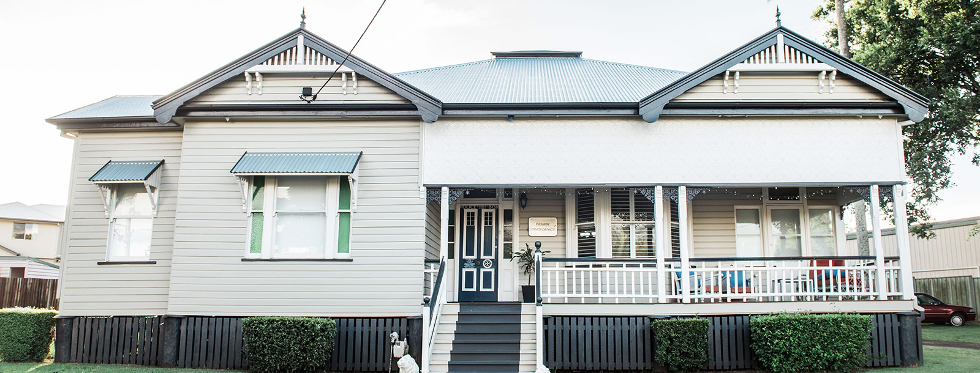

I might feel worried or frustrated.

There are things I can do to help. I can take a breath.

I can think
It’s ok, I can cope.
I will wait in the waiting room and might see the turtle.
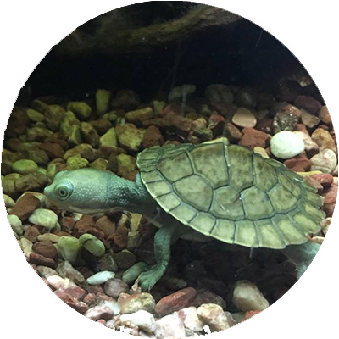
Then it’s time to see Barb.
Hi Barb

Barb will have activities for me to do.
Then it’s time to go. Good bye Barb.
I will say “Bye”.

